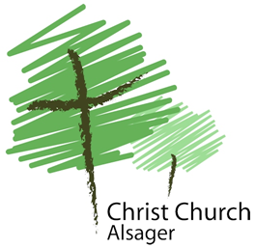
Children and Families Leader, Christ Church Alsager
Full-time (40 hours per week)
Salary £23,000 - £27,000 pa (dependent on qualification and experience). Job-share could be considered.
www.christchurchalsager.uk
Christ Church Alsager is a lively part of the Church of England in South Cheshire. We are on an exciting journey, following Jesus and sharing God’s love with our community. This is an opportunity to work as part of our staff team, overseeing, developing and expanding the well-established ministry of Christ Church with children aged 0 - Year 6 and their families, both within the church and the local community.
We are looking for a committed evangelical Christian with a passion for inspiring children and their families to grow as Christians and a missional zeal to build relationships with both children and adults in our town, sharing the love and truth of God, that they may be inspired to get to know Jesus for themselves.
Recent experience of church-based children’s and families’ work (paid or voluntary) is essential, as is your ability to lead, inspire and grow a voluntary team, sharing responsibility effectively.
For further details and the application pack please contact Rev Daran Ward at vicar@christchurchalsager.uk or call him on 01270 878537.
The closing date for applications is Saturday 21st August 2021.
Interviews will be held on Sunday 12th September 2021.

