What’s on this Christmas at Christ Church

- Christmas is not cancelled at Christ Church! We have services and activities planned and even if last minute changes have to be made, we will still be celebrating. Do join us online or in-person to celebrate Christmas with us this year. Pre-booking essential for all services. To book contact the church office via email: christchurchoffice@hotmail.co.uk or phone: 01270 872291. Check out this website and Facebook page to get the latest information.

- Outdoor Nativity Saturday 5th December

A social-distanced walk-through Nativity with live animals. Your family group will travel around the church grounds stopping at each of five stations to experience the events of the Nativity.

- Carol Services Sunday 20th December 5pm & 7pm

Gather with others to listen to carols and hear the message of Christmas.

- Christmas Eve Crib Services 3pm & 4pm

A short interactive service for all ages reflecting on the events of the Nativity.

- Christmas Eve Communion Services 6pm & 11pm

Formal services of Holy Communion.

- Christmas Day Celebration 10:30am

Come and celebrate Christmas with us.

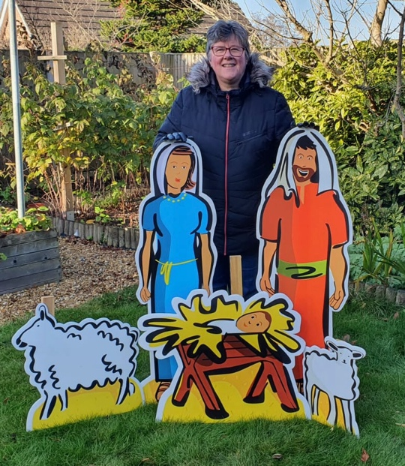

Come and celebrate Christmas with us.

